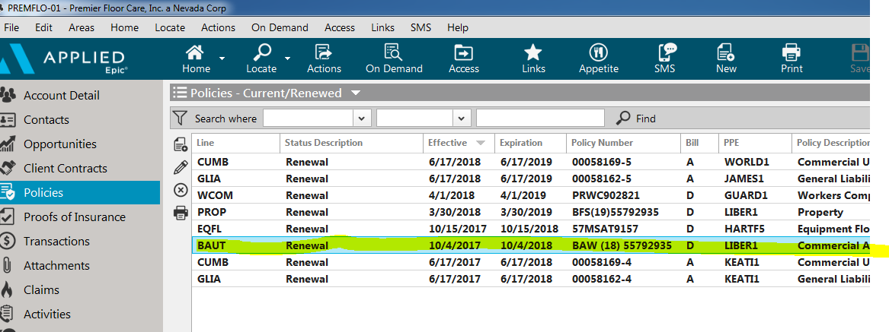

**Action Issue Auto ID card**

**Make sure the “Y” is checked**

