- Plug micro USB cable (included) into the Yamay headset charging dock and then plug in the USB side into a open USB port on your desktop
or any USB charging adapter (ie. for your iphone, etc), then place Headset onto charging dock. You will see a solid red light when it’s charging
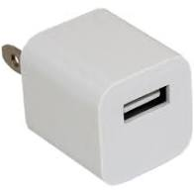
- Pair Headset to CellPhone
  - Pairing to Cellphone – Go to Bluetooth setting and turn on
  - Hold MFB (Silver Button) on headset for 6-8 seconds until LED light flashes Red & Blue
  - Find BH-M9A device on your Bluetooth setting and pair/connect
  - Once connected/paired you should be done and can use Headset to answer calls on your cellphone
- Pair Headset to Desktop/Computer
  - Install dongle into any USB port on your desktop
  - Click on arrow in bottom right corner of your taskbar next to the date/time and click on BlueTooth icon Add BlueTooth Device from dropdown
  - It will take you to the BlueTooth & Other Devices settings on your computer
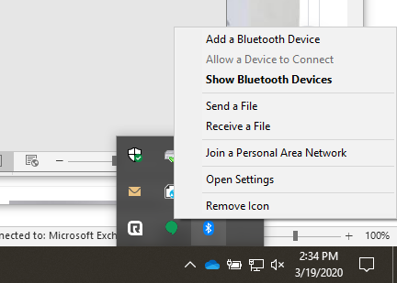

  - Make Sure BlueTooth is “On”
  - Click “Add BlueTooth or other device”
  - Begin pairing mode on the headset Hold MFB (Silver Button) on headset for 6-8 seconds until LED light flashes Red & Blue
  - Select Headset from list of devices
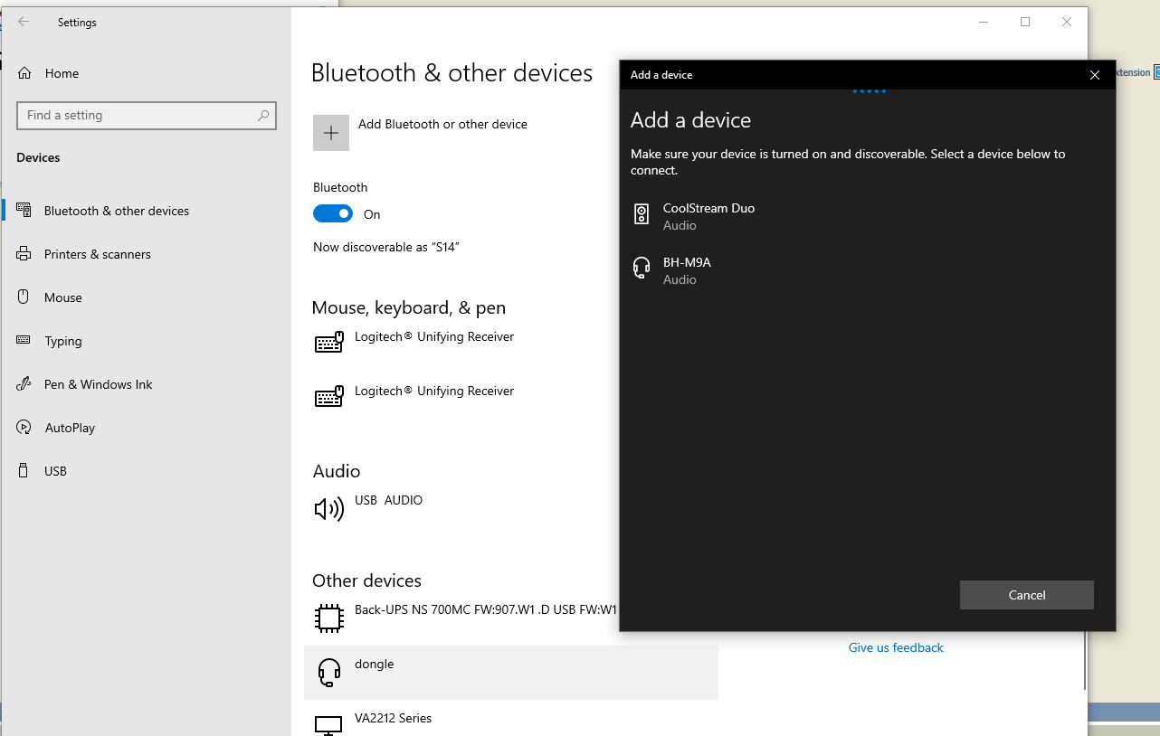
  - Lastly, you will need to change the audio settings on your computer to go through the Headset
  - Click the volume button in the bottom right corner next to date and time and choose “Headset (BH-M9A Hands-Free AG Audio)
