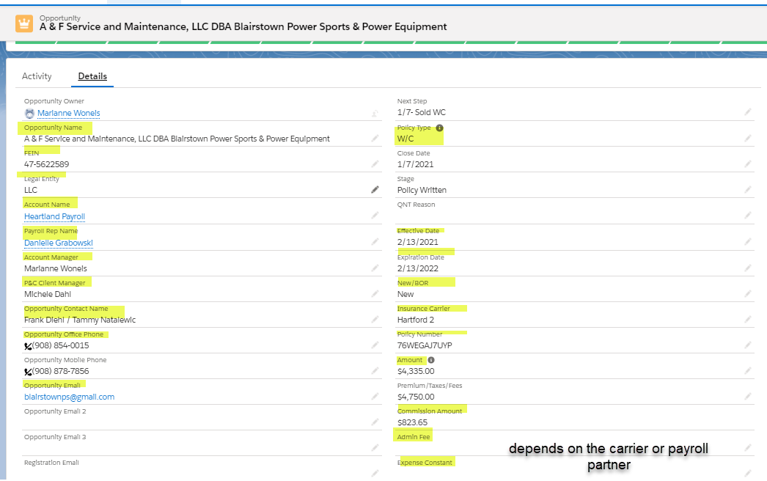

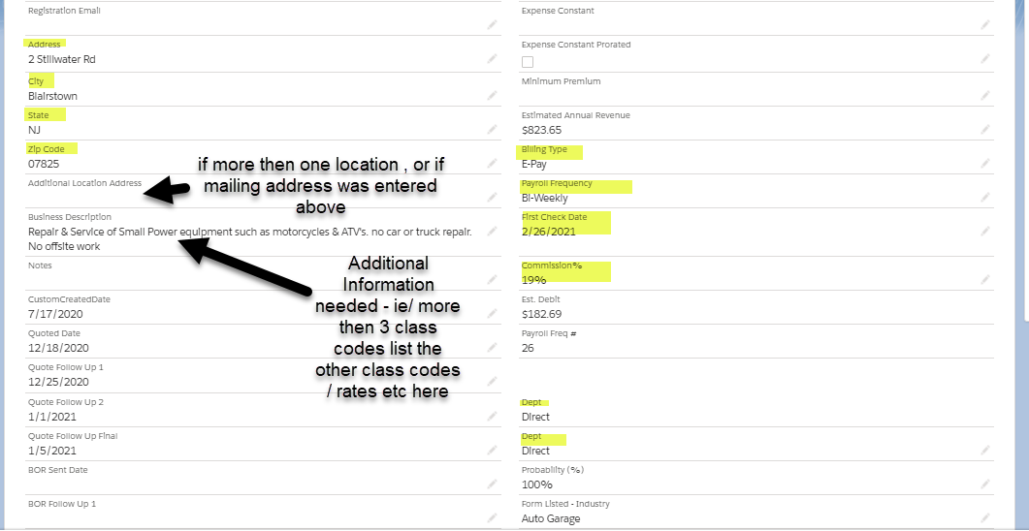

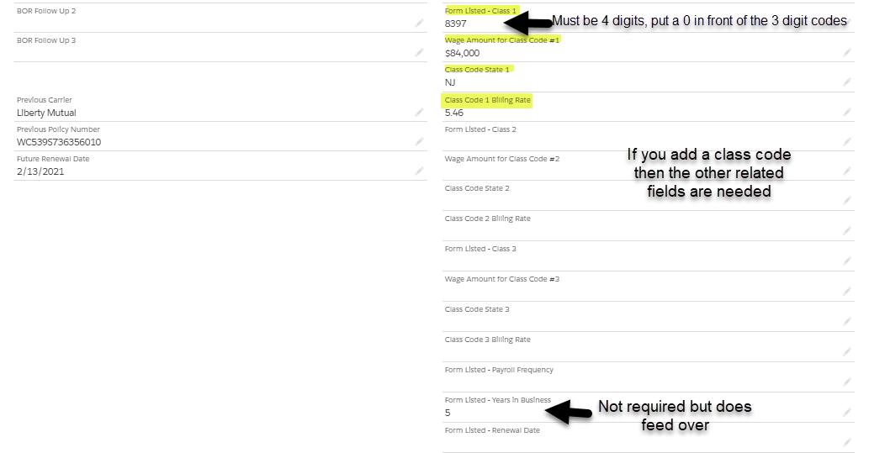

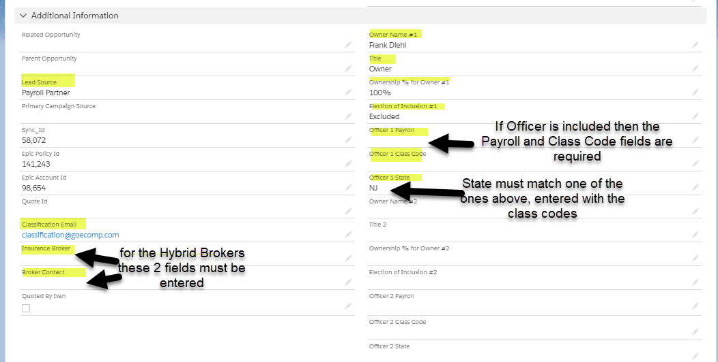

To stop EPAY synch - input "1,111,111,111" now. However, since this has to be a unique number in Salesforce, you'll have to +1 to that number each time you use it on another account ( 1,111,111,112,  1,111,111,113, etc).

Enter 11111 in EPIC ID to Stop Synch